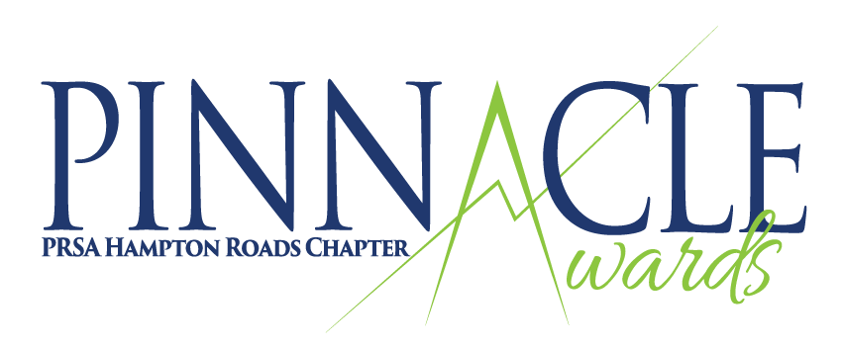

2023 Award Categories

Public Relations Programs
Community Relations Campaign: Activities seeking to win the support or cooperation of, or that aim to improve relations with, people or organizations in communities which the organization has an interest, need or opportunity. Communities refers to a specific geographic location or locations.
Content Marketing: Program that effectively demonstrates a strategic program that includes creating and distributing valuable content to attract, acquire and engage target audience(s). Include examples and metrics.

Crisis Communications Program: Crisis communication programs implemented in response to an unplanned event that required an immediate response.

Events and Observances: Virtual or in-person programs or events, such as commemorations, observances, conferences, openings, yearlong anniversaries, celebrations or other special activities. Events that took longer than a one-week period should be entered in “More Than Seven Days” and events occurring within a time span of one week should be entered in “Seven or Fewer Days”.
Diversity, Equity and Inclusion Campaign: Efforts devoted to promoting inclusivity and/or dismantle discrimination for racial, ethnic, religious or sexual orientation and gender differences.

Internal/Employee Communications: Includes programs targeted specifically to special publics directly allied with the organization (e.g. employees, members, dealers or franchisees).

Most Effective Campaign on a Shoestring Budget ($5,000 or less): Successful campaign despite constraints of a small budget. This does not include staff time and overhead.
Public Affairs: Includes programs specifically designed to influence public policy and/or affect legislation, regulations, political activities or candidacies — at the local, state or federal government levels — so that the entity funding the program benefits.
Reputation/Brand Management: Programs designed to enhance, promote or improve the reputation of an organization with its publics or key elements of its publics, proactively or in response to an issue, event or market occurrence.

Public Relations Tactics
Blogs: Web-based journals that communicate either a corporate, public service or industry position. Screenshot of the blog entry as well as the actual site URL must be submitted with your application.

Creative Writing: Feature articles, speeches, scripts, opinion articles written as editorials, guest columns, letters to the editor or other creative writing pieces. Submit text of article and documentation of its publication with your application.

Digital Platform: Did you launch a new website, app or other digital platform? How was it launched and how much risk was involved in your PR plan? What platforms were used? What value did the end user receive and how did it specifically match goals? Include metrics and benchmarks.

Direct Mail/Direct Response: Communications designed to solicit a specific, immediate response by the target audience. This can be a single communication or a series. Upload a sample copy of the mailing(s) along with your entry.

Magazines: Print or digital publications designed to provide in-depth information about an organization or topic on a regular basis. Magazines typically differentiate from newsletters by the number of pages and length of articles. Upload samples of three consecutive issues along with your application.

Media Relations: Tactics, programs and events driven entirely by media relations. Submit press releases, media advisories, pitch letters, etc. along with the actual media coverage.

Newsletters: Print or digital publications designed, written and published periodically to provide brief and timely information to target audiences while supporting an organization’s overall objectives. Submit three consecutive issues with your application.

Public Service Announcements: Video and audio productions of one minute or less that were distributed as unpaid public service announcements, single productions or a series addressing the same issue. Include audio/video files or URL with your application.

Single-Issue Publications: Print or digital versions of annual reports, pamphlets, brochures, booklets, calendars, or other publications designed for a special purpose to inform a target audience about an organization, annual performance, program(s), product, service or issue. Submit one copy of the publication with your application. Note: Newsletters and Magazines are in separate categories. Annual Reports are now included in THIS category.

Social Media: Use of social media as part of a public relations program. Include screen shots and/or copies of key pages and URLs with your application.

Video: Videos targeted to internal or external audiences. Provide URLs for online viewing.

Website: Use of a website as part of an internal or external public relations program. Include the website URL for external sites or screenshots and how the site met or exceeded your communications benchmarks.

Individual Awards

P. LEE STARKEY PINNACLE in PUBLIC RELATIONS
The Starkey Pinnacle Award honors a current member of PRSA Hampton Roads who has worked in the public relations field for 10 years or more and who has demonstrated outstanding professional achievement and chapter contributions.

Criteria
- The recipient must demonstrate outstanding public relations, leadership and management skills in a project or program that was challenging and/or difficult in nature.
- The recipient must have made an outstanding contribution to the chapter through participation and contributions to committees and/or the board of directors.
- Have the Accreditation in Public Relations (APR).

Applications
Eligible members may nominate themselves or be nominated by a colleague. Application packages must include:
- Applicant’s contact information (name, phone, email)
- A resume indicating the applicant's education and employment history
- A chronology of the applicant's participation in PRSAHR activities, and/or other PRSA activities at the national or district level.
- Two letters of support from individuals who have personal knowledge of and/or involvement with the applicant's contribution to professional work or PRSA involvement.

PRSA HAMPTON ROADS MEMBER OF THE YEAR
Member of the Year honors a current member of PRSA Hampton Roads who has worked in the public relations field for five years or more and who has demonstrated outstanding chapter contributions.
Criteria
Applicants will be judged on attendance at chapter meetings and events, participation on committees and/or the board of directors, and outstanding contributions to a committee, program, or other chapter initiative. Having an APR or pursuing APR is desirable, but not required.

Applications
Eligible members may nominate themselves or be nominated by a colleague. Application packages must include:
- Applicant’s contact information (name, phone, email)
- A chronology of the applicant's participation in PRSAHR activities, and/or other PRSA activities at the national or district level.
- Two letters of support from individuals who have personal knowledge of and/or involvement with the applicant's contributions to the chapter.

DIVERSITY CHAMPION AWARD
The Diversity Champion Award honors a current member of PRSA Hampton Roads who has served as a role model in championing multicultural awareness in the Hampton Roads community. This communications practitioner has a track record of promoting the needs of diverse communities and has five years or more work experience.

Criteria
Applicants will be judged on participation in D&I events, service in an organization or committee that fosters D&I or serves a diverse audience, record of service to carry on D&I initiatives in internal/external communications, and/or participation in mentorship programs.

Applications
Eligible members may nominate themselves or be nominated by a colleague. Applications package should include:
- Applicant’s contact information (name, phone, email)
- A statement (no more than two pages) that describes how the applicant contributes to promoting diversity and inclusion in the workplace or community. Please list all associations, events, and efforts that are applicable to the award.
- Two letters of support from individuals who have personal knowledge of and/or involvement with the applicant's contributions to professional work or PRSA involvement.

RISING STAR AWARD
The Rising Star Award honors a current member of PRSA Hampton Roads who
has worked in the public relations field for less than five years and who has demonstrated a commitment to the field of public relations and an aptitude for leadership through their involvement in, and contributions to, the chapter.

Criteria
Applicants will be judged on attendance at chapter meetings and events, participation on committees and/or the board of directors, and outstanding contributions to a committee, program or other chapter initiative.

Applications
Eligible members may nominate themselves or be nominated by a colleague. Application package should include:
- Applicant’s contact information (name, phone, email)
- One page nomination letter explaining why you feel your applicant is a Rising Star.
- One letter of support from an individual who have personal knowledge of and/or involvement with the applicant's contributions to professional work or PRSA involvement.

